Water Is Such a Blessing!
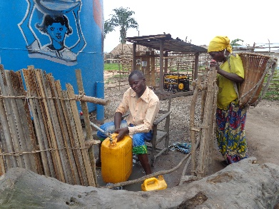
The very exciting project of building a well in Diengenga has brought such blessing to the residents of Diengenga, about 600 miles from Kinshasa. On July 7, the local clergy organized and conducted a beautiful service of blessing for the well. Many people gave testimony to the improvement in their lives now that they do not have to trudge to the river several kilometers away to gather dirty, dangerous water. They have clean, fresh water to drink, wash their clothing and bathe. They are so excited! We actually videotaped some testimonies from people who always concluded their witness with “Water Is Life!” So, so true!

Liturgies of Beauty
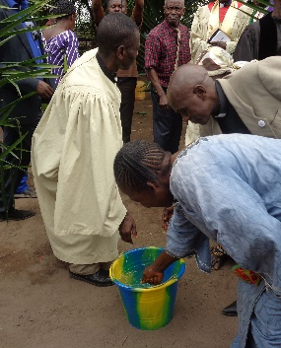
The service of blessing was so, so special! After sharing scripture where Moses struck the rock and provided water for the thousands of Jews crossing the desert, he circled the cistern, splashing water as a symbol of sanctification. Jonathan then had an opportunity to preach on the story of Jesus and the Samaritan woman, when He encouraged her to drink the water of Life. He then reminded them of the liturgy in the Book of Worship of the United Methodist Church call “A Reaffirmation of Our Baptism.” And so, he welcomed all of the participants to dip their hand into a bucket of water extracted from the well, make a sign of the cross upon their forehead and remember the promise of their baptism—that each was a beloved child of God. Such a precious time as the people participated in the ritual and praised the Lord!
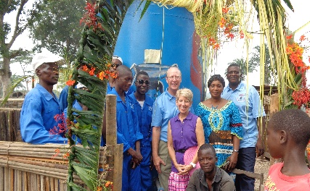
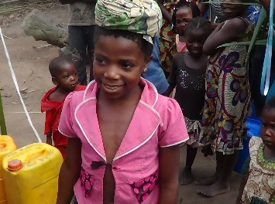
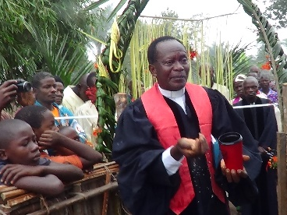

The pastor splashed the cistern Celebrating the arrival of A happy girl gathering
with water to bless the contents. fresh water for the village! water at the well!

Phase 2!
Before the Bakers left Diengenga, the people were busily digging and trench and burying the PVC pipe so that the water could be available outside the gated farm. That will be much better accessible to the people.
And so, now they can just turn the faucet and fill their bucket to capture the fresh water!
They are excited about the future of improved health and lesser burdens related to the long trek to the river to fetch the dirty, infected water.

More Villages ~ The well digging in Diengenga has been very successful and we are so grateful for all those who supported this effort through their generous giving and prayers.
But this is just ONE village! There are hundreds of villages in Democratic Republic of Congo that still do not have access to clean water, which leads and contributes to infections and disadvantaged health.
Was your heart touched? If so, you may contribute to funding efforts for additional well drilling in DRC by giving to your local United Methodist Church designated to the Congo Partnership—Well Drilling.

